Skin Disease Detection & Classification using CNN

In this project we are using CNN (convolution neural networks) to classify skin diseases from images as CNN gain lots of success and popularity in the field of image classification. To train CNN we have used skin disease dataset which contains 9 different types of diseases such as 'Actinic Keratosis', 'Basal Cell Carcinoma', 'Dermatofibroma', 'Melanoma', 'Nevus', 'Pigmented Benign Keratosis', 'Seborrheic Keratosis', 'Squamous Cell Carcinoma' and 'Vascular Lesion'. After training CNN algorithm we can upload any test image then CNN will detect and classify disease from that image.

In below screen I am showing dataset used in this project

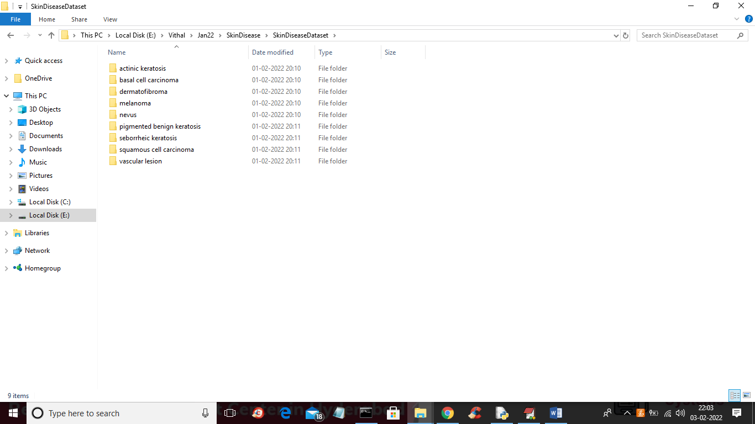

In above screen 9 different folders are there with different diseases names and just enter any folder to see that disease images. You can see below screen

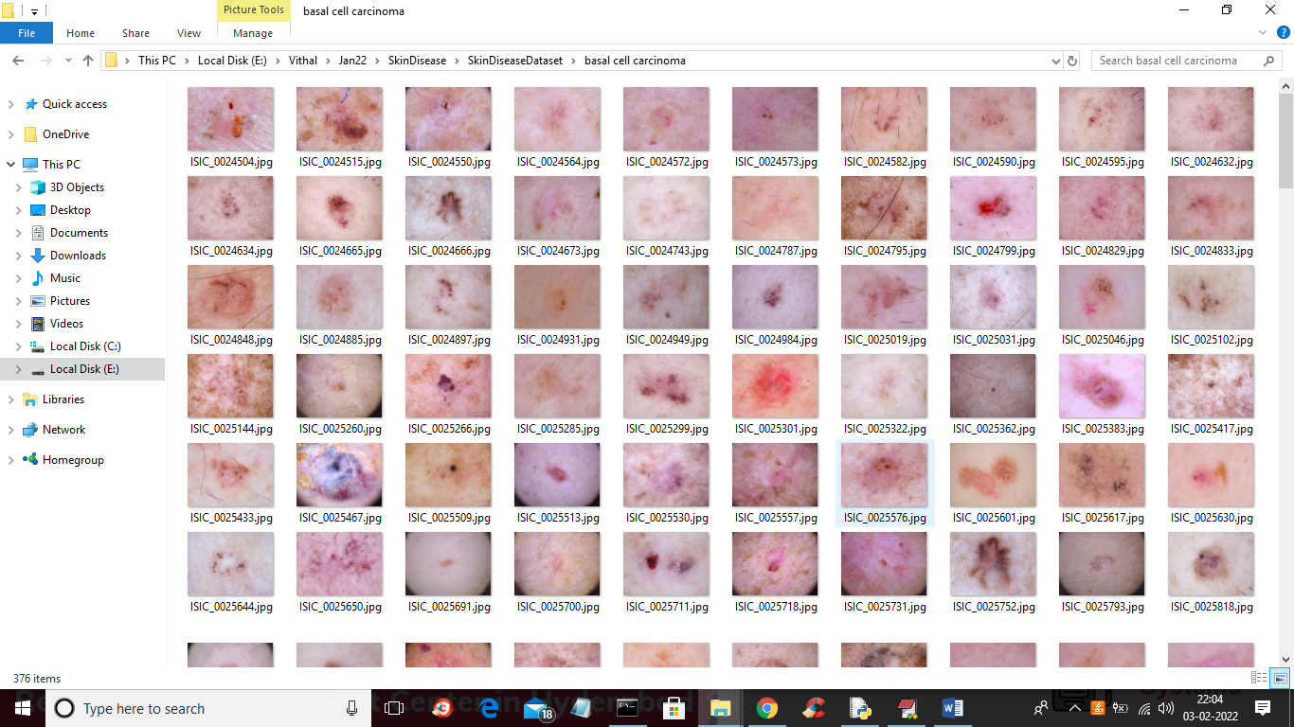

We are using above images to train CNN and below screen showing CNN code for training

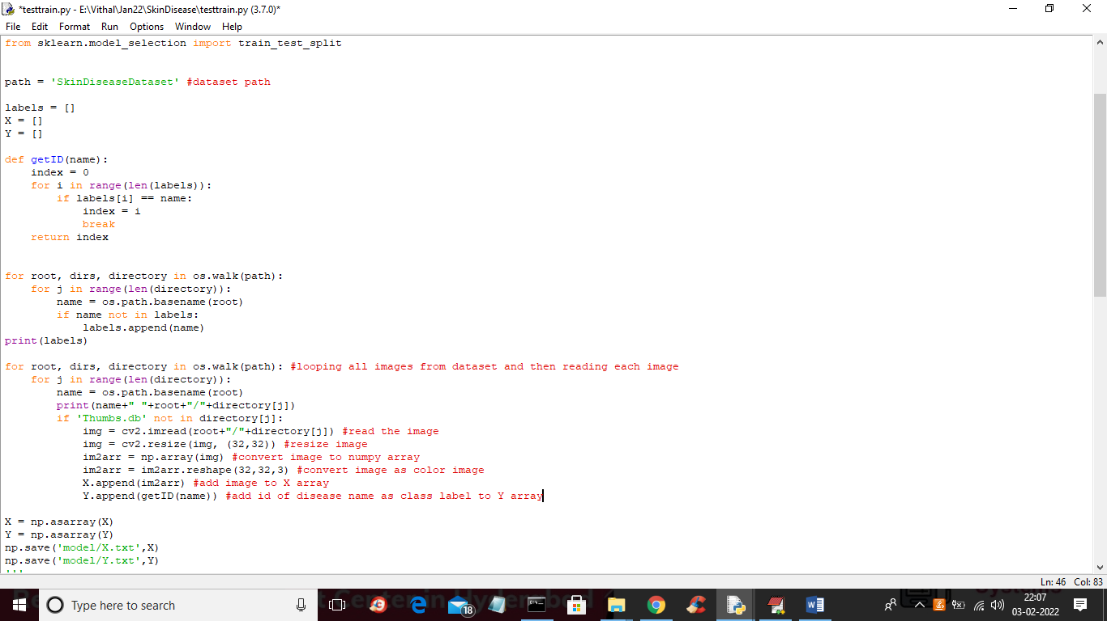

In above code read red colour comments to know about reading and processing images and then saving to X and Y array and in below screen we can CNN is getting training with X and Y array values

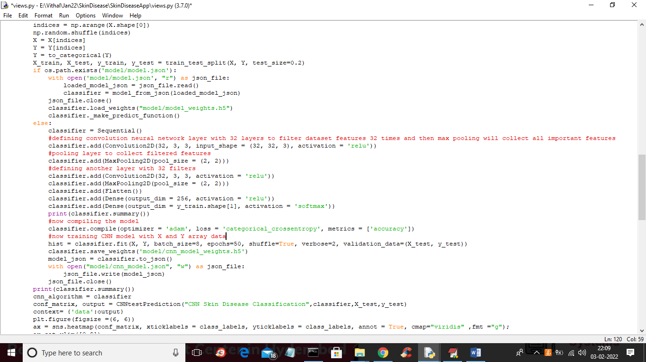

In above code you can see we are defining Convolution Neural Network (CNN) object and then training with X and Y array values.

SCREEN SHOTS

To run project double click on ‘run.bat’ file to start DJANGO web server and to get below screen

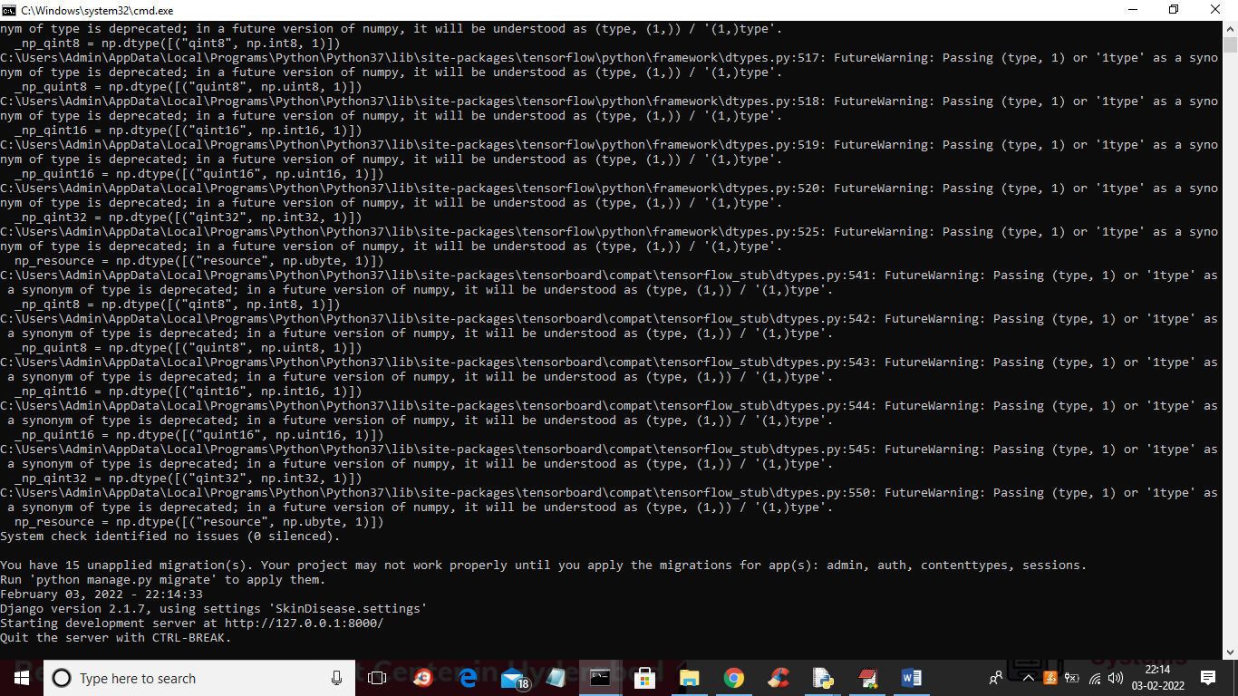

In above screen DJANGO server started and now open browser and enter URL as <http://127.0.0.1:8000/index.html> and press enter key to get below screen

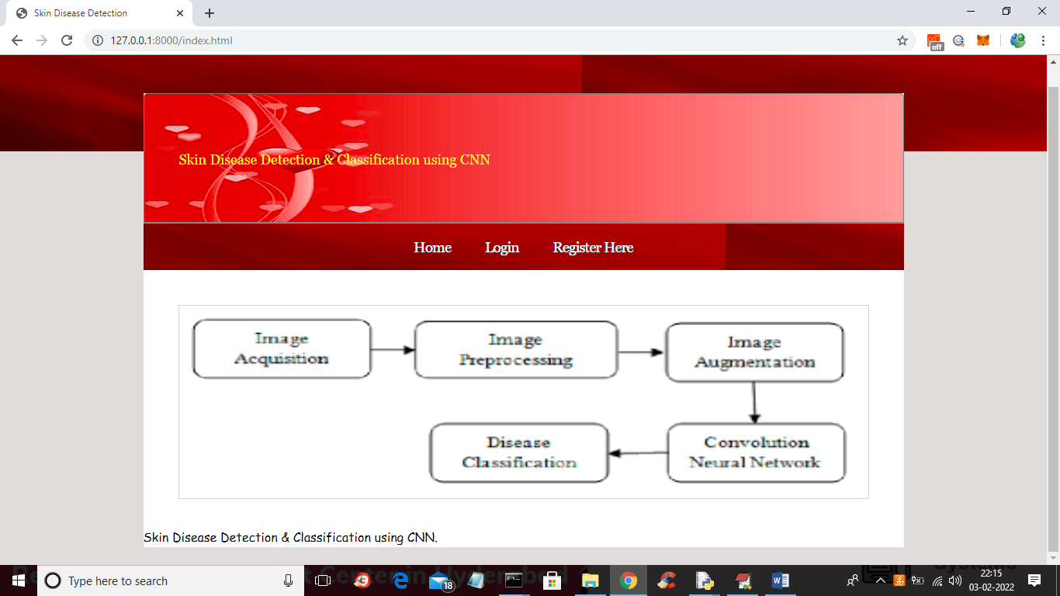

In above screen click on ‘Register Here’ link to get below signup screen

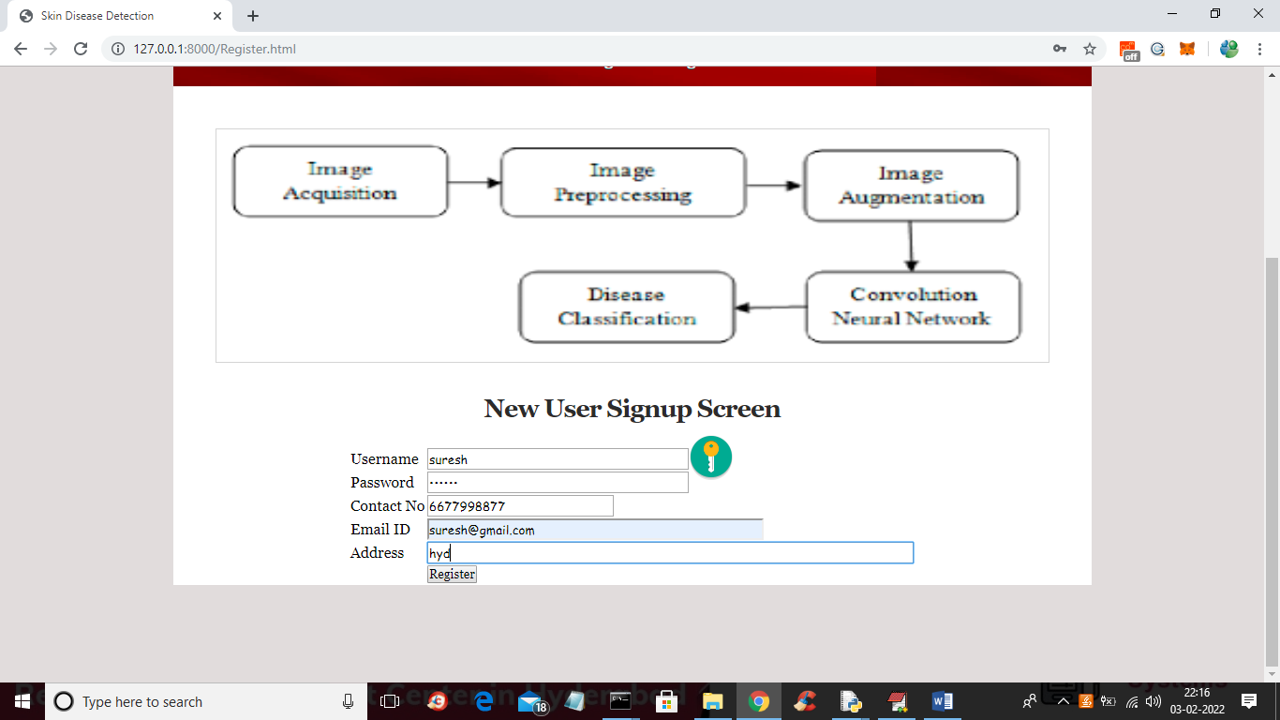

In above screen user is enter signup details and then press ‘Register’ button to complete signup process and to get below output

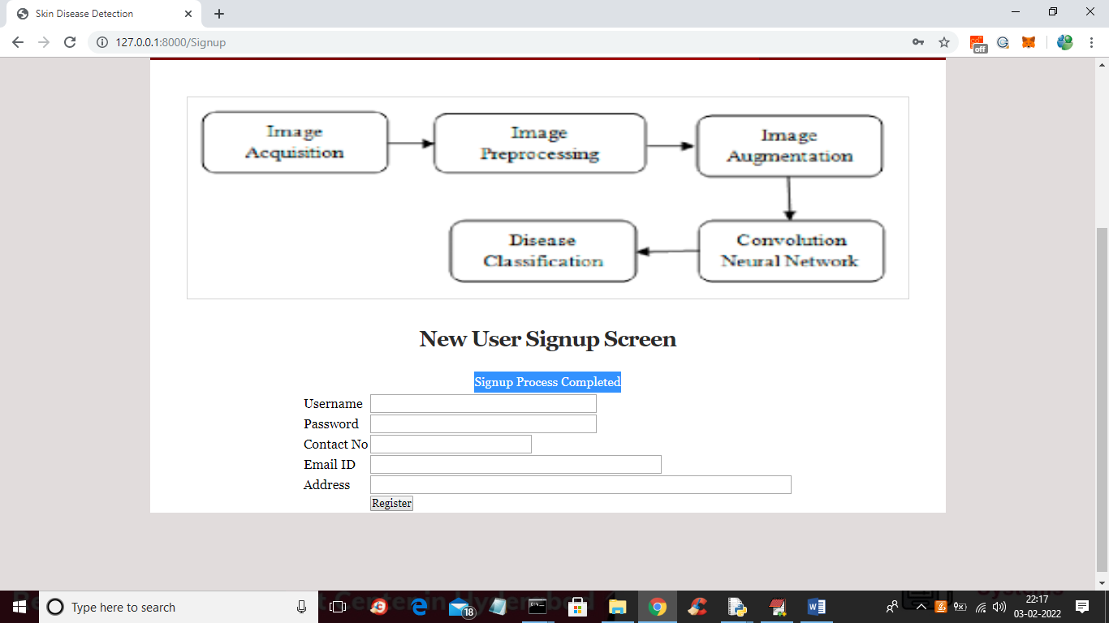

In above screen in blue colour text we can see signup process completed and now click on ‘Login’ link to get below screen



In above screen user is login and then click on ‘Login’ button to get below screen

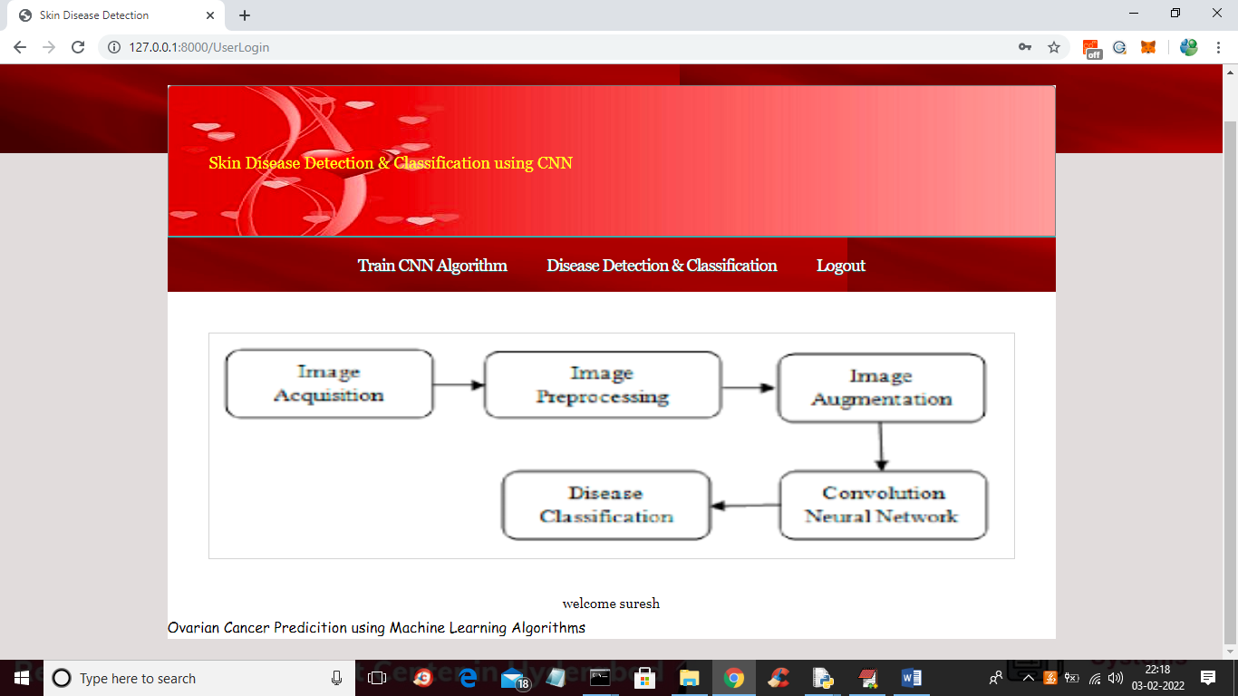

In above screen user can click on ‘Train CNN Algorithm’ link to train CNN and to get below output

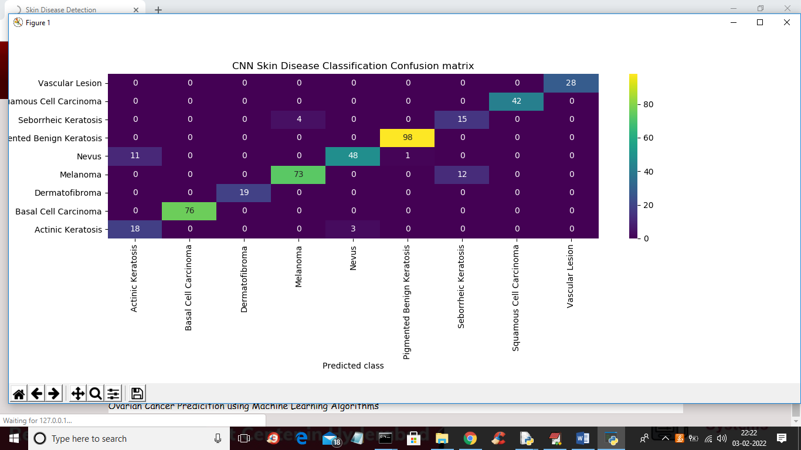

In above CNN confusion matrix graph we can prediction on test data and in above graph x-axis represents predicted disease names and y-axis represents original test classes and in above all values in diagnol boxes are the correct prediction and value > 0 which are not in diagnol are the wrong prediction and we can see only few records are wrongly predicted. Now close above graph to get below CNN accuracy

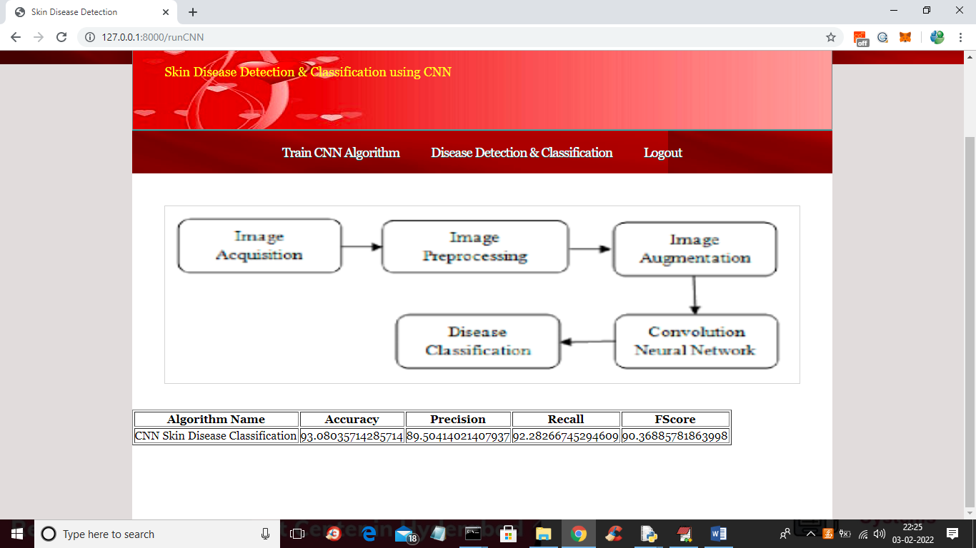

In above screen we got CNN accuracy as 93% and in below screen we can see CNN architecture

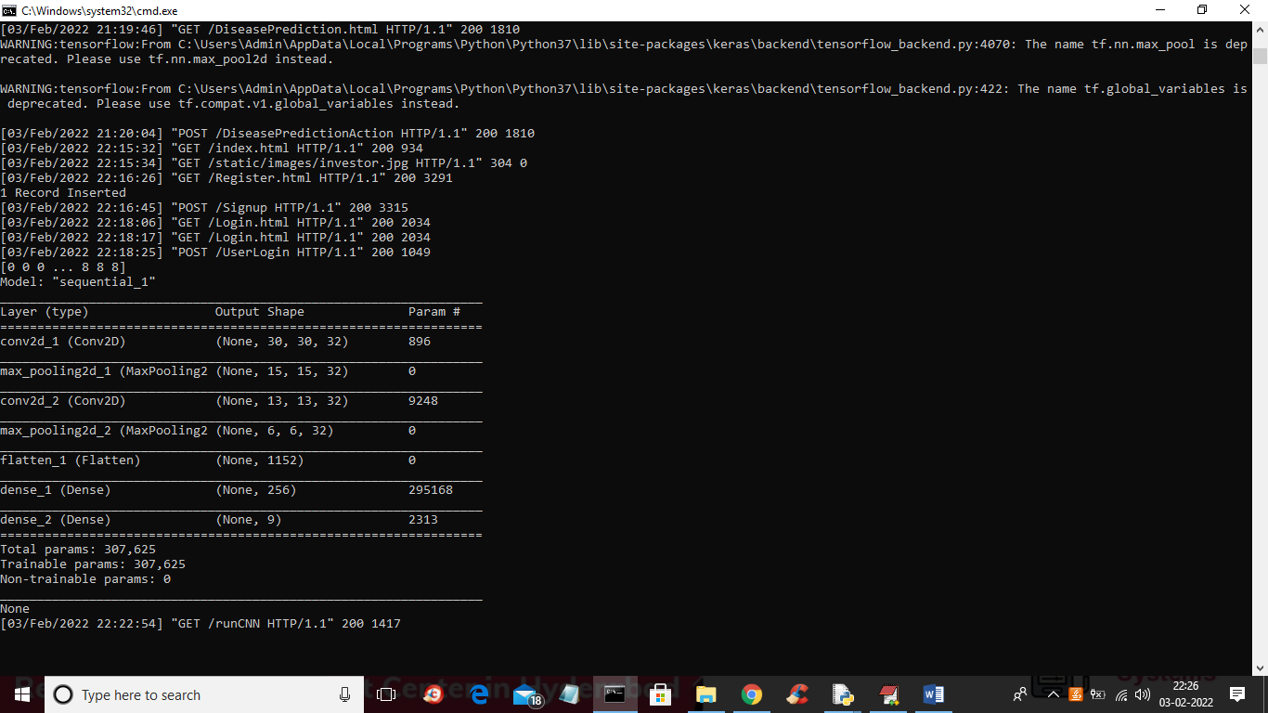

In above CNN architecture we have designed multiple layers with different image sizes such as 30 X 30, 15 X 15 etc. Now go back to output application and then click on ‘Disease Detection & Classification’ link to get below output

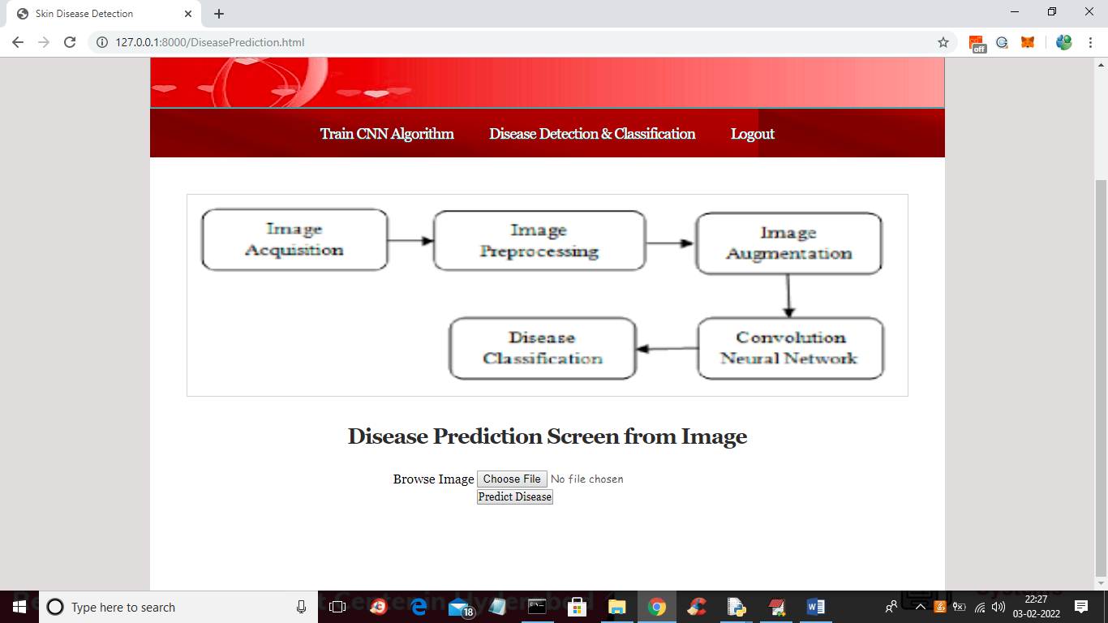

In above screen click on ‘Choose File’ button to upload skin diseases images from ‘testImages’ folder and then click on ‘Predict Disease’ button to classify disease

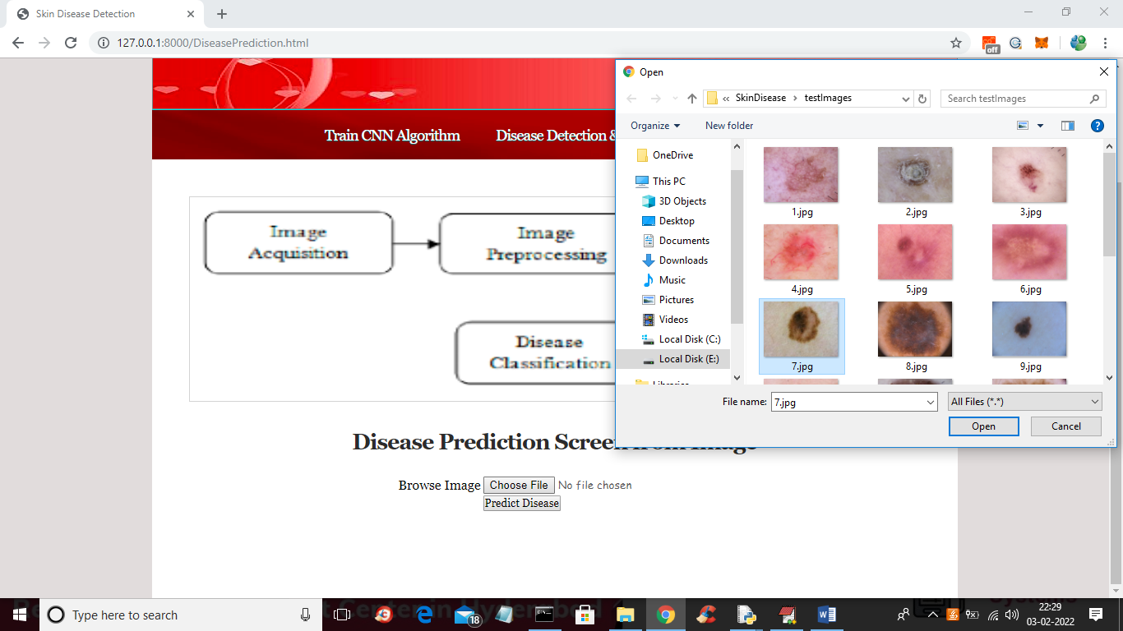

In above screen selecting and uploading ‘7.jpg’ and then click on ‘Open’ button to load image and then click on ‘Predict Disease’ button to get below output

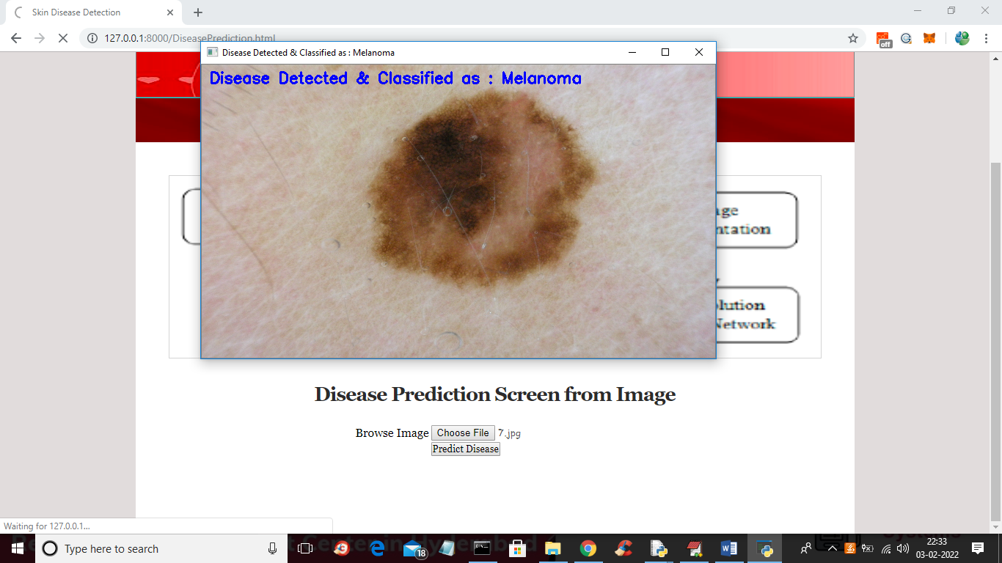

In above screen in blue colour text we can see CNN classify disease on image as ‘Melanoma’ and similarly you can upload and test remaining images

